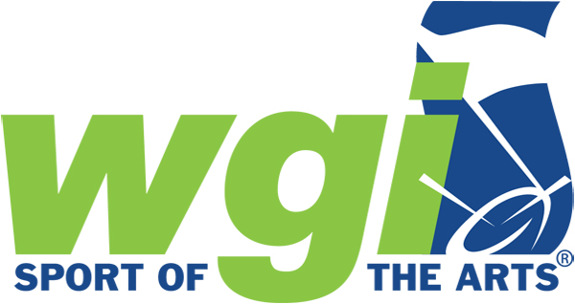

WGI Regional event comes to <CITY> <DATE>

WGI Sport of the Arts brings together youth nationwide for extraordinary performance and competition

WGI Sport of the Arts centers on providing a venue for young people to pursue excellence in both performance and competition through nationwide color guard, indoor percussion, and winds regional competitive events.

“WGI Sport of the Arts continues to be a catalyst for extracurricular activity in most high schools with over 100,000 dedicated students wanting to participate in the marching arts in local, national, and international events,” said WGI Executive Director Ron Nankervis. “From a humble beginning 45 years ago with 34 groups, WGI has grown to now see more than 1,500 groups participating in 2022.”

The <REGIONAL NAME> brings the top <COLOR GUARD/PERCUSSION/WINDS> ensembles in the region together in the spirit of camaraderie through competition.

The Regional will take place at <VENUE & ADDRESS> on <DATE(S)>. For a full list of participating schools, please visit: http://www.wgi.org/current-entries/

Ticket information for the <REGIONAL NAME> is available online at wgi.org. Pricing is as follows:
Preliminaries - $15
Finals - $18
Combination package - $28

The <REGIONAL NAME> is a qualifying event for the 2022 WGI World Championships held in Dayton, OH in April. For more information, visit www.wgi.org or find us on Facebook (@wgisportofthearts), Twitter (@wgitweets), and Instagram (@wgisportofthearts).

###

ABOUT WINTER GUARD INTERNATIONAL (WGI) – WGI Sport of the Arts is the world’s premier organization producing indoor color guard, percussion, and wind ensemble competitions. It is called the Sport of the Arts because it brings music to life through performance in a competitive format. Now entering its 45th year in 2022, our non-profit competitive organization continues to evolve and grow. This season there will be more than 40,000 participants at the regional level, and more than 11,000 participants at the WGI World Championships in April 2022.

