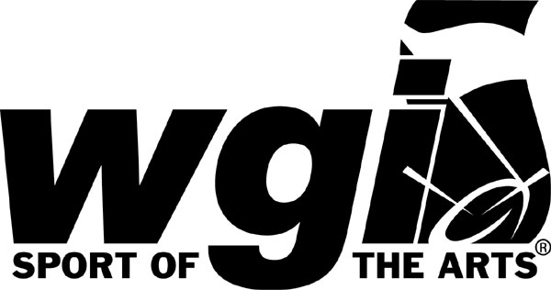

The two forms included here are WGI’s generic regional expo info form and program ad form. If you plan to use these, each of the items in parenthesis () must be updated with correct information.

WGI provides these forms for all of our Event Partners to use and is now providing it to our Circuit Partners as well. Please feel free to use these as needed. We just ask that you change it to read for your circuit info.
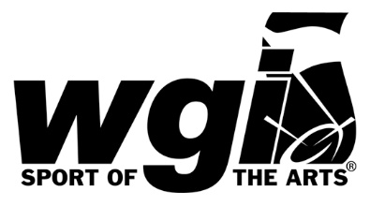
WGI (CITY NAME) Regional Expo Information

WGI is expecting a great turn out at the (CITY NAME) Regional, on (DATES). With (NUMBER) competing groups, the expo is sure to be an exciting place in a high traffic area of (SCHOOL OR ARENA VENUE). One six-foot undraped table and two folding chairs will be provided compliments of the Regional Event Partner. Electricity may be provided upon advance request only. Booths are limited and assigned in a first come first serve manner, according to reservation postmark. Payment information is required with the reservation. Priority booth placement is given to WGI Sponsor and Strategic Partners.

(price) per 10’ x 10’ space

Regional Expo Reservation Form

Company Name

Contact Person

Address

City ______________________ State ___________ Zip

Phone ________________________________ Fax

Email

Please select one: Electricity Access YES NO

Space Reservation Deadline: (DATE)

Number of booths requested ______ at (price) each = $

Payment Information

Check enclosed
Please charge VISA MasterCard Discover

Credit Card # ___________________________________ Exp Date

Three-digit security code on the back of the card __________

Authorized Signature _______________________________ Date

For more information on how to reserve your expo booth at this regional contact (regional contact person and phone/email)
For information about the WGI World Championships events, please contact the WGI office.

WGI (CITY NAME) Regional Program Book

Showcase your products and services before hundreds of spectators, participants, and directors at the WGI (CITY NAME) Regional by advertising in the Official Program Book. This book captures images of performers, reports information about the event and activities, and serves as a timetable for the Regional weekend. The WGI (CITY NAME) Regional will be held (DATE).

Publication Deadlines
Space Reservation (DATE)
Art Deadline (DATE)
Advertising Insertion Order (Please print)

Advertiser __________________________Contact Person
Address
City _________________________________State _______Zip
Phone ___________________________________Ext _____ Fax
Email
(REGIONAL NAME) Program Rates
(REGIONAL NAME) Program Book
Full $(PRICE) Half $(PRICE) Third$(PRICE) Quarter $(PRICE) Total $
Please specify if half page ads are vertical or horizontal: Vertical Horizontal
Special Instructions:

Dimensions of artwork needed
Full (pixel X pixel) Half (pixel X pixel) Quarter (pixel X pixel)
Please be sure to submit you’re artwork via email to (Name with email address) or mail a CD to (Name with snail mail address)

Payment Information
Full payment is required with insertion orders for all new advertisers.
Check enclosed
Please charge VISA MasterCard Discover

Credit Card # _______________________________ Exp. Date_______ CVV
Authorized Signature __________________________________________Date

Contact Information
For questions concerning the (blank) Regional Program, contact (name, phone, email)

